After completing your problem using the story problems steps, make one complete paragraph using the format below. Start each sentence as demonstrated.


I am trying to find out…

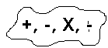
My plan is to…


This is a good strategy because…
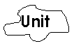

My solution is… I checked my work and my answer makes sense.

